Problem situation

**implement from zero, in Java language, two operations:**

The natural logarithm defined as:

[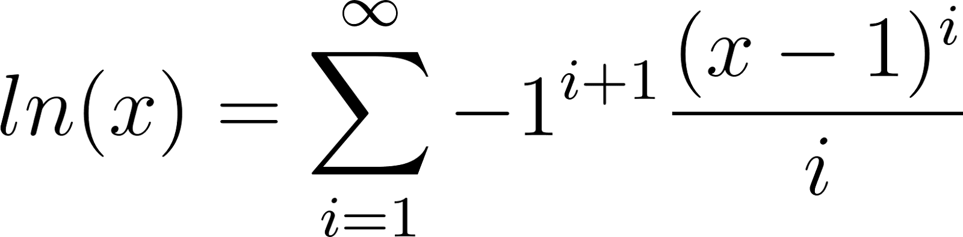](https://www.codecogs.com/eqnedit.php?latex=ln(x)%20%3D%20%5Csum_%7Bi%20%3D%201%7D%5E%7B%5Cinfty%7D%20-1%5E%7Bi%2B1%7D%20%5Cfrac%7B%20(x%20-%201)%5Ei%20%7D%7Bi%7D#0)

And the sine function defined as:

[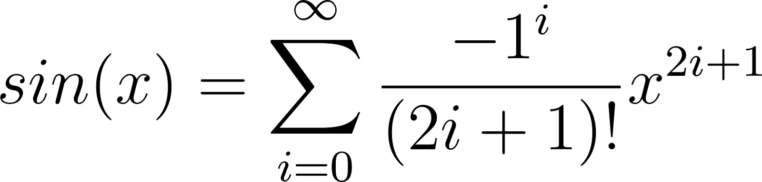](https://www.codecogs.com/eqnedit.php?latex=sin(x)%20%3D%20%5Csum_%7Bi%20%3D%200%7D%5E%7B%5Cinfty%7D%20%5Cfrac%7B-1%5Ei%7D%7B(2i%20%2B%201)!%7D%20x%5E%7B2i%2B1%7D#0)

.

Flowchart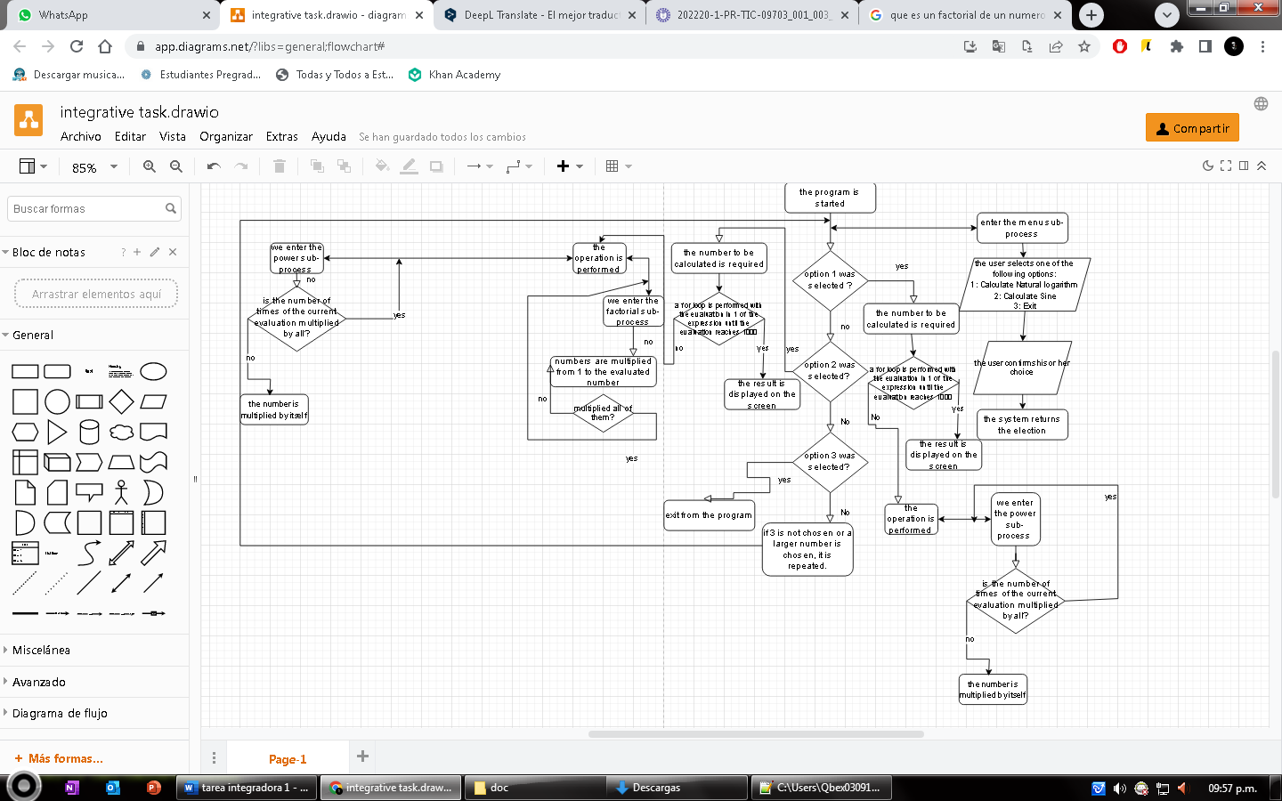

Tabla entradas y salidas

Inputs:

|  |  |  |
| --- | --- | --- |
| Data type | Description of its function | Name of variable |
| int | Saves the menu selection | Options |
| double | Saves the value to be calculated | value |
| String | saves the user's decision when asked if he/she wishes to proceed | continued |

outputs:

|  |  |  |
| --- | --- | --- |
| Data type | Description of its function | Name of variable |
| double | shows the final value of the sine function | resultsen |
| double | shows the final value of the natural logarithm function | ln |

Example

Test Data:

1. natural logarithm of 1.5
2. sine of 1.42

Resultado estimado:

1. the result is 0.4054651081
2. The result is 0.98865176

Real results:

1. 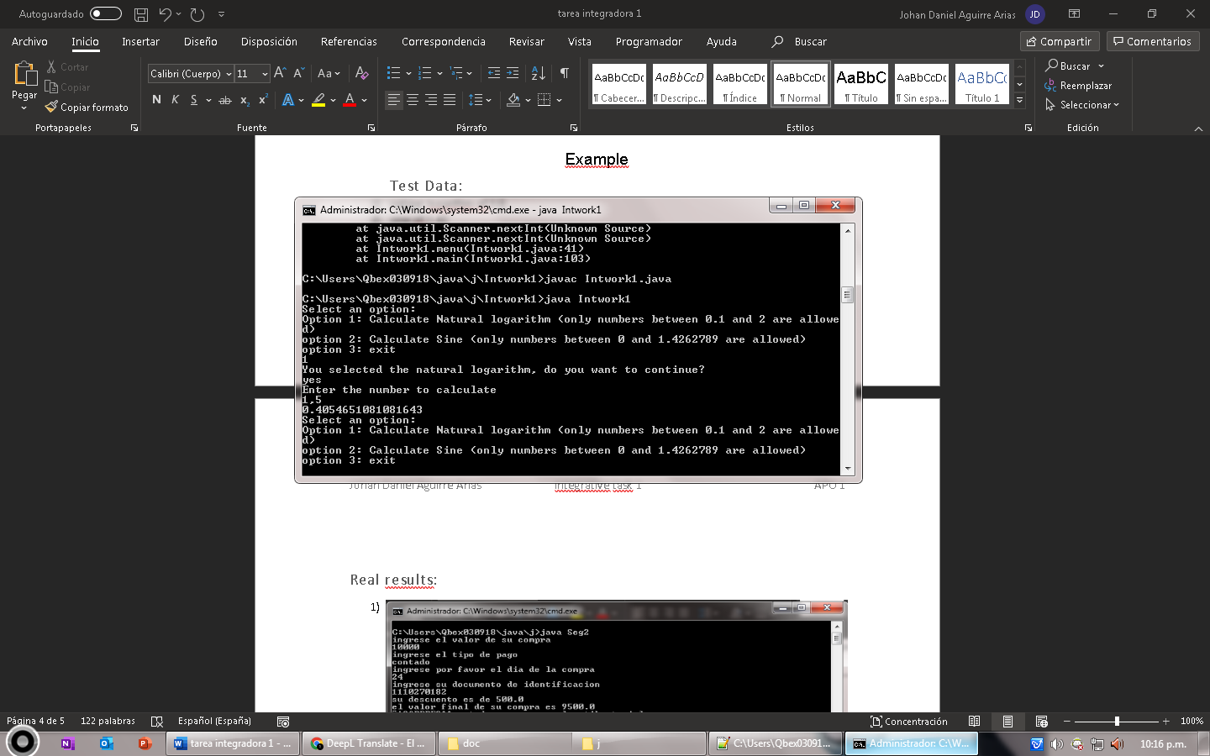
2. 